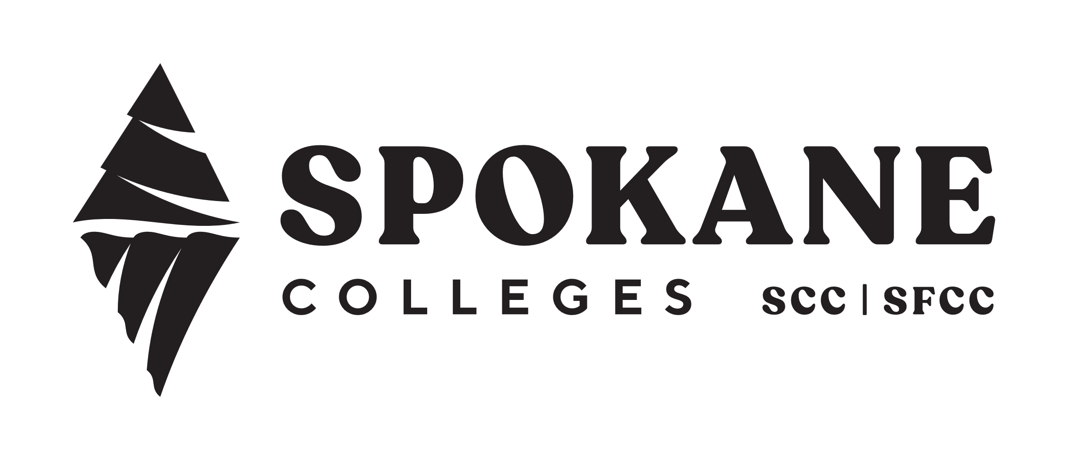
FORMAL STUDENT COMPLAINT FORM FOR NON-FACULTY EMPLOYEES
Date of Administrator or Supervisor’s Step 2 Response to Informal Student Concern:
Date of Student’s Formal Complaint:
Student Statement/Complaint:
(attach additional pages as necessary)
Administrator/Supervisor’s Intake and Assessment: The administrator/supervisor assesses the formal complaint and makes a determination of whether the complaint is appropriate for further consideration.
Date the Administrator/Supervisor Received the Student’s Formal Complaint:
The student’s complaint is not appropriate for further consideration.
- Notify the student in writing no later than ten (10) instructional days after receipt of the formal complaint. Attach response to this form. Complaint is terminated and may only be considered further by appeal to Vice President/Chief Officer (see below).
Date of Administrator/Supervisor’s Determination Notification:
The student’s complaint is appropriate for further consideration.
Date Administrator/Supervisor Forwarded Copy of Complaint to Employee:
Employee Response: The employee submits to administrator/supervisor a written response to the formal complaint within ten (10) instructional days of being notified by them. Attach written response to form. The employee will provide the administrator/supervisor a written response to the complaint.
Date Employee Received Supervisor’s Notification:
Date of Bargaining Unit Notification:
Date of Employee’s Response to Complaint:
Division Response: A meeting to discuss the complaint and draft the division’s official response is scheduled by administrator/supervisor within ten (10) instructional days of receiving the employee’s written response. Meeting includes the administrator/supervisor, employee and bargaining unit representative if applicable. Others may participate at the mutual agreement of the administrator/supervisor and employee.

Date Administrator/Supervisor Received Employee’s Written Response:
Date of Bargaining Unit Notification:
Date of Division Response Meeting:
The administrator/supervisor will provide the division’s formal response to the student within five (5) instructional days after the above meeting. Attach the response to this form. This serves as the official division response to the complaint.
Vice President/Chief Officer Appeal: If the complaint is not resolved to the student’s satisfaction, they may appeal to the Vice President or Chief Officer of the district unit within ten (10) instructional days after the division’s response. The Vice President/Chief Officer’s response will be attached to this form and serves as the college’s final official response to the complaint.

